**Set Up for Developers**

1. Ask Venki to invite you as a collaborator on the GitHub repository. Accept the invite.
2. Install VS Code
3. Install latest Python 3.13+
4. Install the Basic Git software
5. Inside VS code install extensions: GitHub Copilot, GitHub Repositories, GitHub Pull Requests, see below:
6. A screenshot of a computer

   AI-generated content may be incorrect.
7. Inside VS code, Shift+Control+P (pallete), and search for GitHub: Clone
8. Clone the ‘LUMA_Timesheet_Automation’ repository. You should see the below:

1. Click on main.py and you should see the code as below:

1. Open a new Terminal Window:

1. Make sure you are in the dir where you cloned the repository: With ‘dir’ cmd should see

1. Create a virtual environment using:

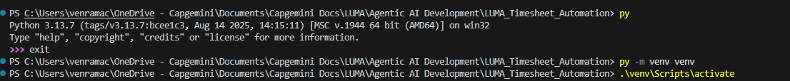

Once the venv is created, you should activate it using the above ‘activate’ cmd

1. Your prompt in the terminal should have, the green (venv) text in front as seen here:



1. Install all the packages needed for the tool using the above pip command
2. The final packages when installed should show the below screen

1. Run the main.py command using:



1. You should see the csv file created in the file system as below:

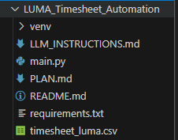

1. Open it up and you should see:

1. Make sure you have some Outlook meeting entries titled ‘LUMA Timesheet Entry’ and some text in the body.
2. Make some changes to the main.py code and save the file ‘Control-S’:
3. Do a ‘git status’ as below:

1. It shows that there were changes in the repo dir. Main.py had changes and a new file ‘timesheet_luma.csv’ got added (output of our py run)
2. Just check in the changes to the py code:

1. You added (add) using the git add command. You committed and provided a message using the ‘git commit’ cmd and then finally pushed the changes to the remote repo using ‘git push’.
2. Changes you pushed are visible in the GitHub web site account folder as below:

1. Congratulations, your laptop is now set to develop python application using VS Code.

**Vibe coding Start**

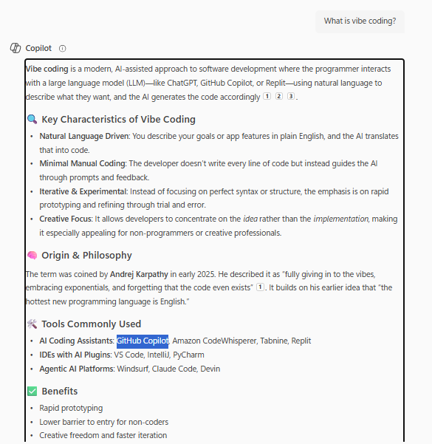

/asyncpr

├── PLAN.md # Must-haves, nice-to-haves, out-of-scope

├── LLM_INSTRUCTIONS.md # Prompts and guidance for AI agents

├── /src

│ ├── /backend # FastAPI or Spring Boot

│ ├── /frontend # React or Blazor

│ └── /shared # Common utilities

├── /evals

│ ├── image-processing-eval.md

│ ├── business-name-detection-eval.md

│ └── feedback-generation-eval.md

├── /tests # User journey validations

├── /docs # API specs, schemas, business rules

├── /scripts # Utility scripts

├── /mcp-servers # Local server configs for Claude

└── README.md

**Workflow Steps**

**1. Define the Vision**

* Write a clear **PLAN.md** with goals and constraints.
* Include **user stories** and **acceptance criteria**.

**2. Start with Evaluations (Evals)**

* Define what “good” output looks like before coding.
* Examples:
  + Receipt image → Extracted business name
  + Business name → Valid business email
  + Customer feedback → Structured JSON

**3. Prompt GitHub Copilot**

* Use natural language like:

“Create a FastAPI endpoint that accepts a receipt image and returns the business name.”

* Let Copilot generate the code, then refine iteratively.

**4. Use Claude for Planning**

* Ask Claude to:
  + Review architecture
  + Suggest refactors
  + Validate business logic

**5. Build Section-by-Section**

* Implement one feature at a time.
* Validate against Evals.
* Commit only when it passes.

**6. Containerize & Orchestrate**

* Use Docker to containerize backend and frontend.
* Optionally orchestrate with Docker Compose or Kubernetes.

**🧠 Mindset Tips**

* Treat AI tools like **interns**: powerful but needing guidance.
* Reset early if AI output drifts.
* Keep Git branches clean and use GitHub Actions for validation.
* Refactor relentlessly for clarity and modularity.

I saved the Plan.md and LLM_instructions.md in my local file system for later use

**🚀 Next Step: Set Up Your Environment**

Would you like help setting up:

1. A **Python project** in VS Code with GitHub Copilot?
2. **Microsoft Graph API access** (app registration, permissions)?
3. A **starter script** to fetch and filter meetings?

Let me know which you'd like to tackle first, and I’ll guide you through it!

Follow all the instructions, they take up a lot of time if you are already familiar with coding in python using VS Code.

1. Installed VS code

2. Installed latest python in my Cap laptop

3. Installing GitHub desktop gave me a lot of problems. Not sure what I did wrong.

Finally installing only Git not Github desktop

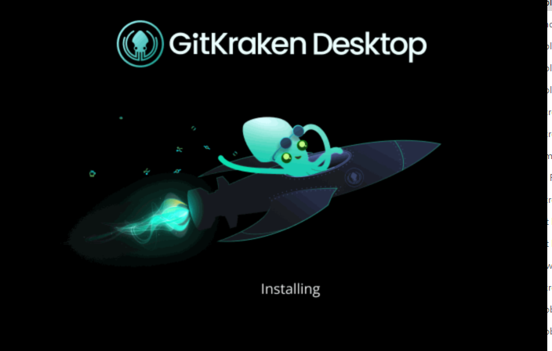

Why did I install this? Probably need to keep it running in the background

Install just Git from: <https://git-scm.com/download/win> (accepted all defaults)

Exit and restart VS Code..error disappears

Use Shift+Cntrl+P, get the pallet, Get the GitHub Copilot: Sign In

And sign in to your GitHB account. Now test the auto complete by creating a python code and see if it completes the code:

The greyed out text the code suggested by AI, Hit TAB to accept it.

All the suggested code gets accepted and it suggest the next ‘print line’

Hit TAB, Control+S to save the file and run it in the terminal.



Congrats, you created the first py code with GitHub Copilot suggesting all the code and tested it and it ran correctly.

Check if the path is set and the venv is always activated before you start coding



(venv) in green should be in front of the prompt.

Next Steps:

**Mount SharePoint web site as a network drive in your laptop:**

